Week 16 Individual Logbook
Capstone project
Matt Baker
2026
Table of Contents
Hours Breakdown 2
Completed Content/Documentation 3
Team Meetings 3
Advisor Meetings 3
Client Meetings 3
Research 3
Documentation 4
Testing 6
Development 6

Hours Breakdown
Category | Hours completed
Team meetings
Client meetings
Advisor meetings
Research
Development
Testing
Documentation
Logbook preparation | 1hr
Sick leave/specific conditions
Other
Total Hours for this week
Running total of hours completed for  Capstone | 367hrs/450hrs

Completed Content/Documentation

Team Meetings
Advisor Meetings

Client Meetings

Research

Documentation
Monday, October 26
11:45 –
Work on the academic closeout report, sourcing documentation for how tools were found and testing was conducted.
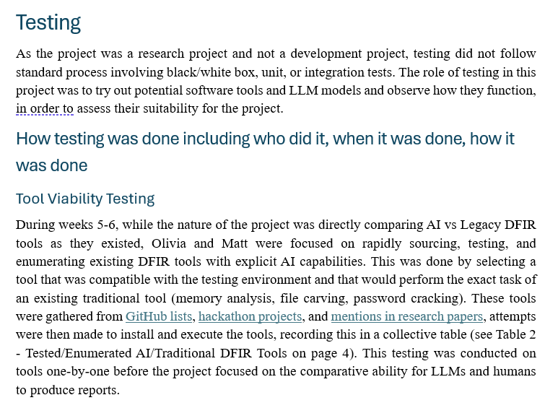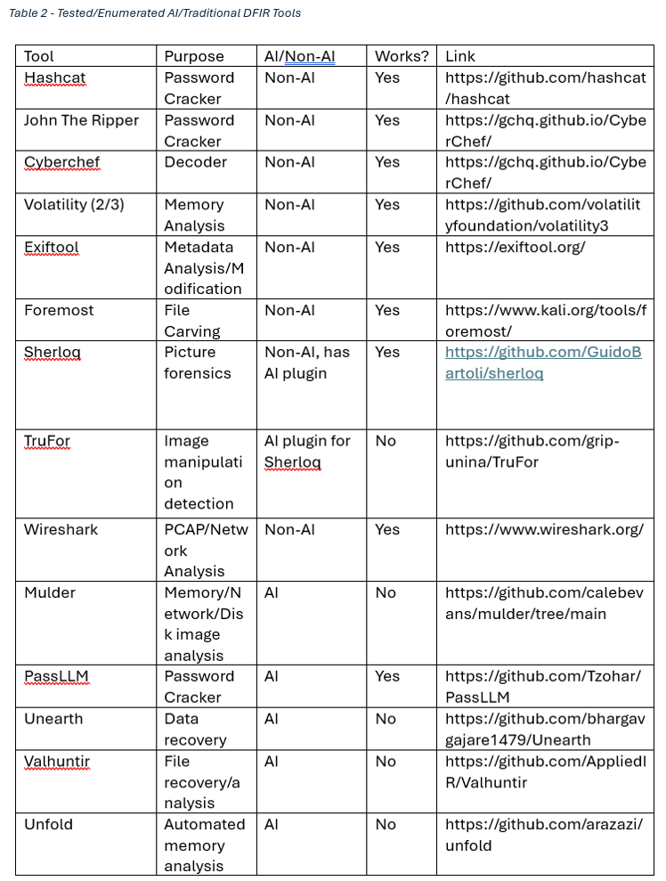

Testing

Development

